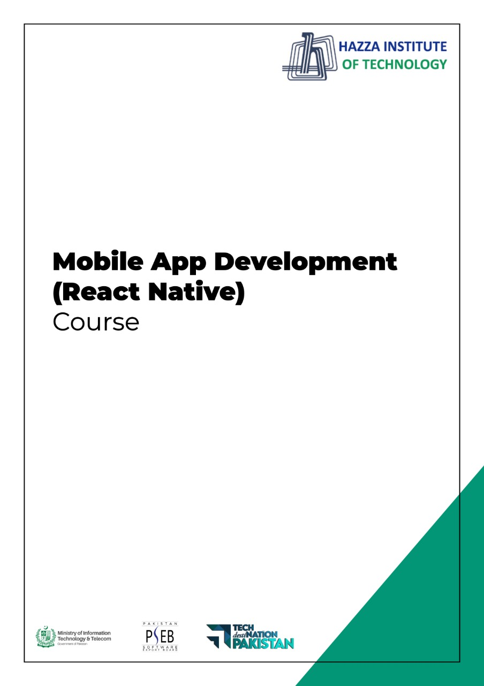
(Flutter)
Lab 16

Total Time:
3 hours

Pre-Lab Activities:

  - Familiar with Admob Ads Monetization

Learning Outcomes:
  - Student will learn how display BANNER and INTERSTITIAL ads.

Student Activities:
  - Create an Admob account
  - Integrate google mobile ads in flutter app

App to be made

Home Screen with Banner Ad
and a button in the center
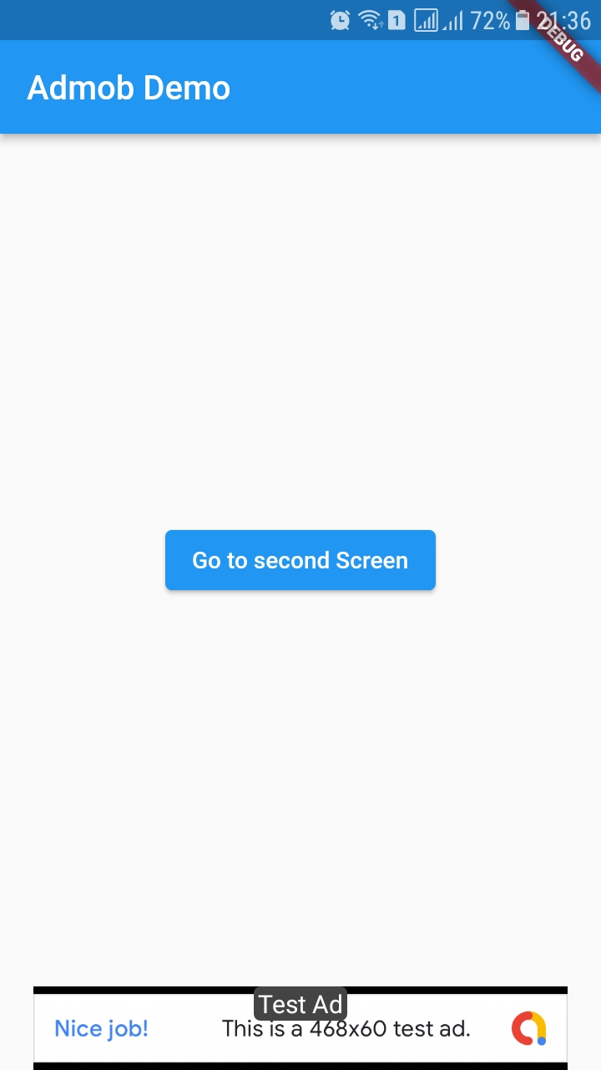

When button is pressed a full screen ad ( Interstitial ad ) is displayed and then second screen is shown then
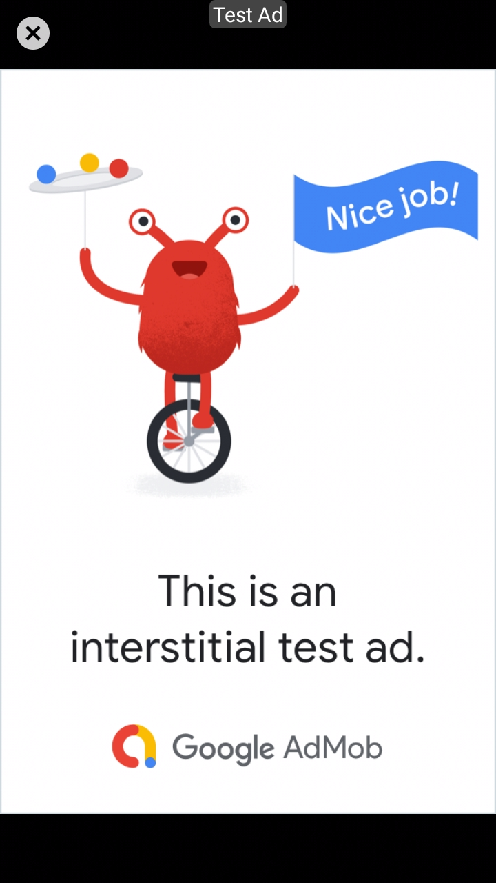

First we need to create an Admob account
Following steps are required

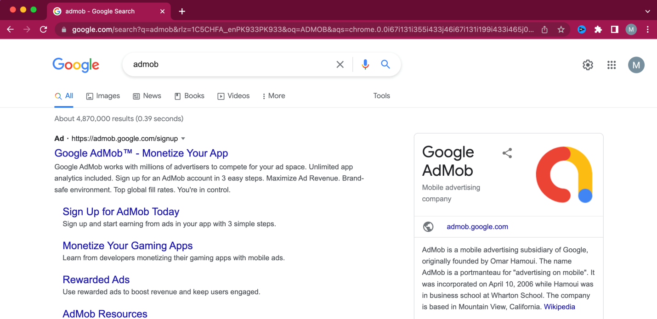
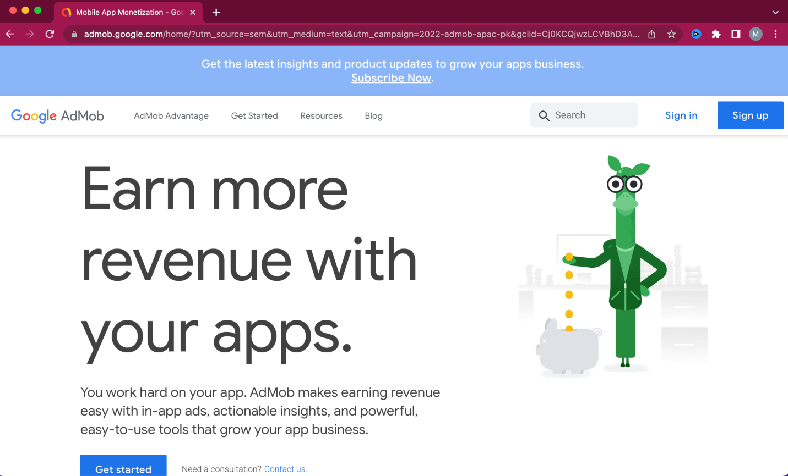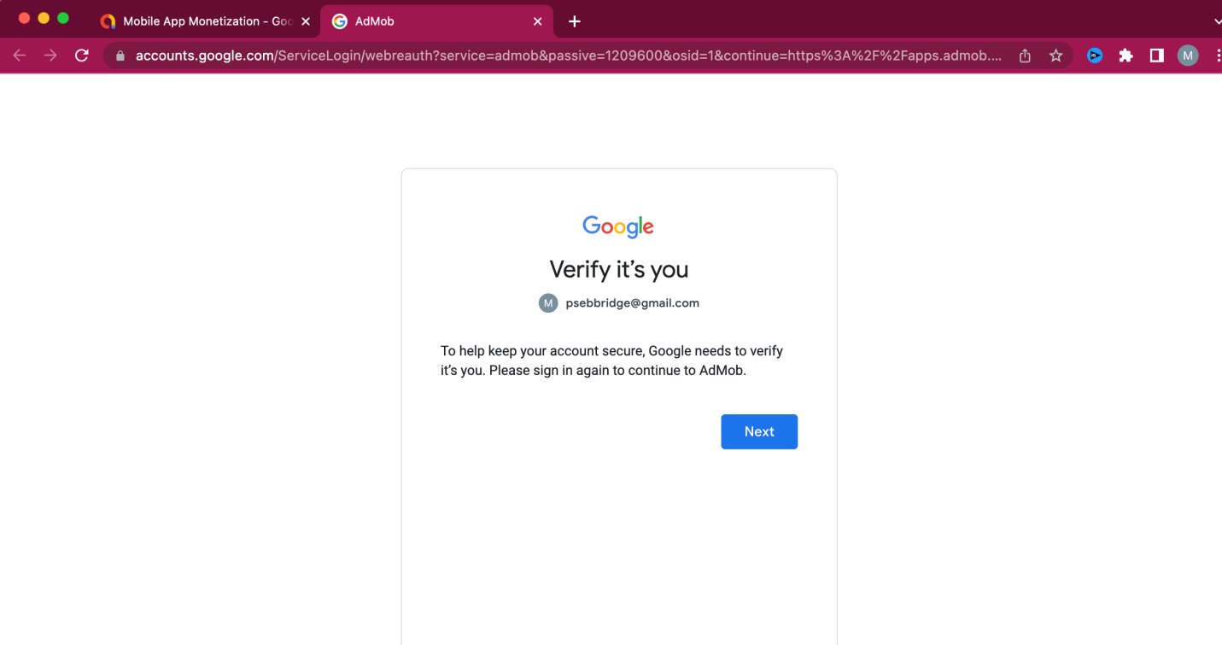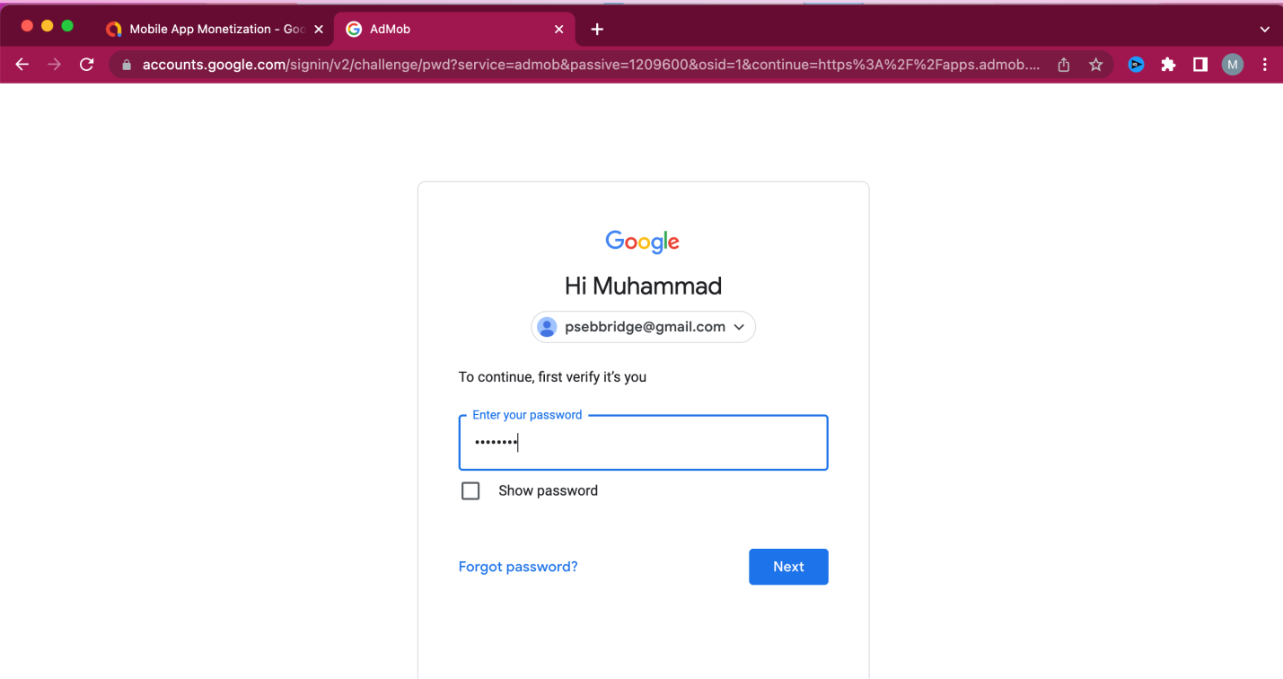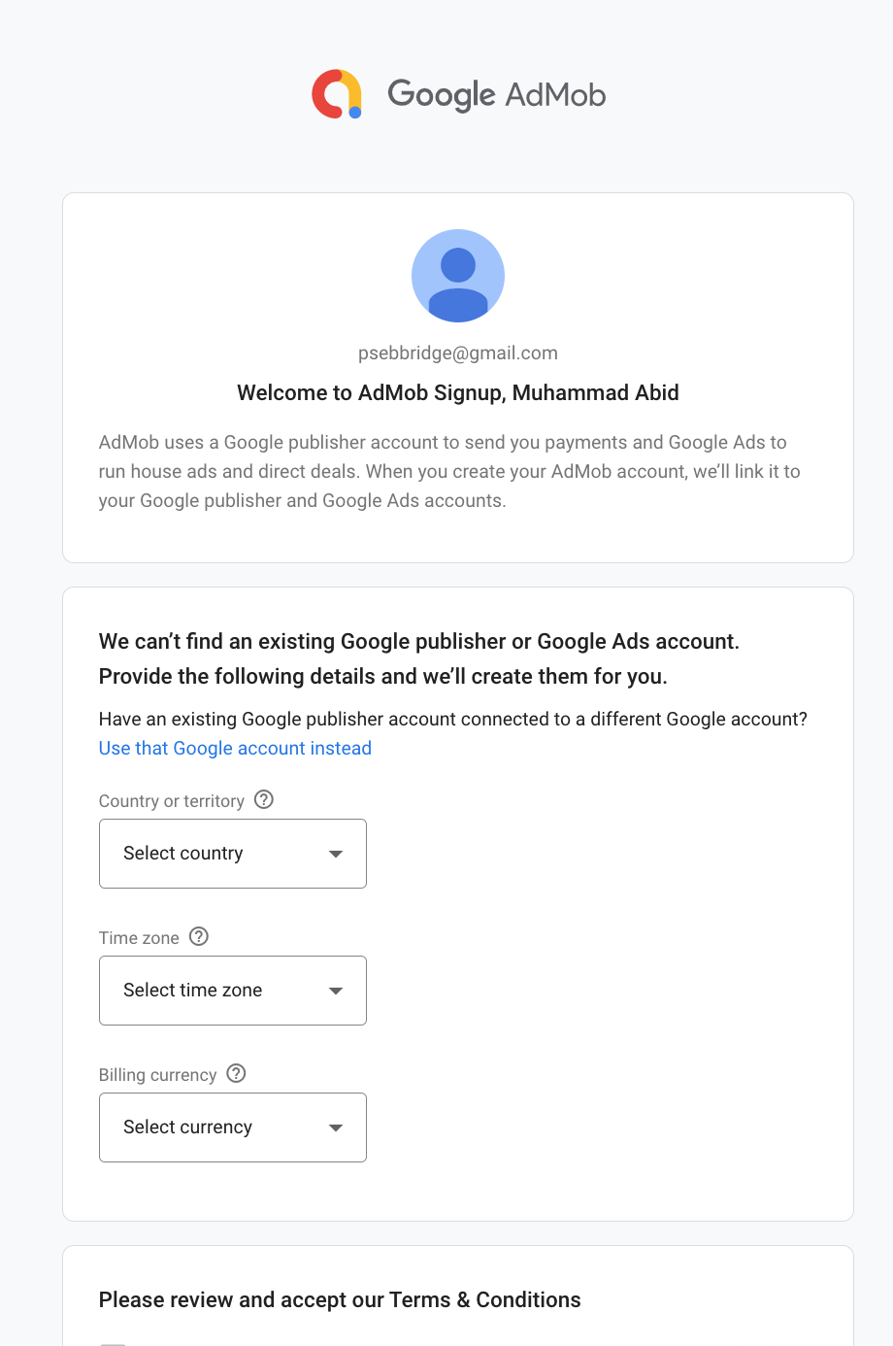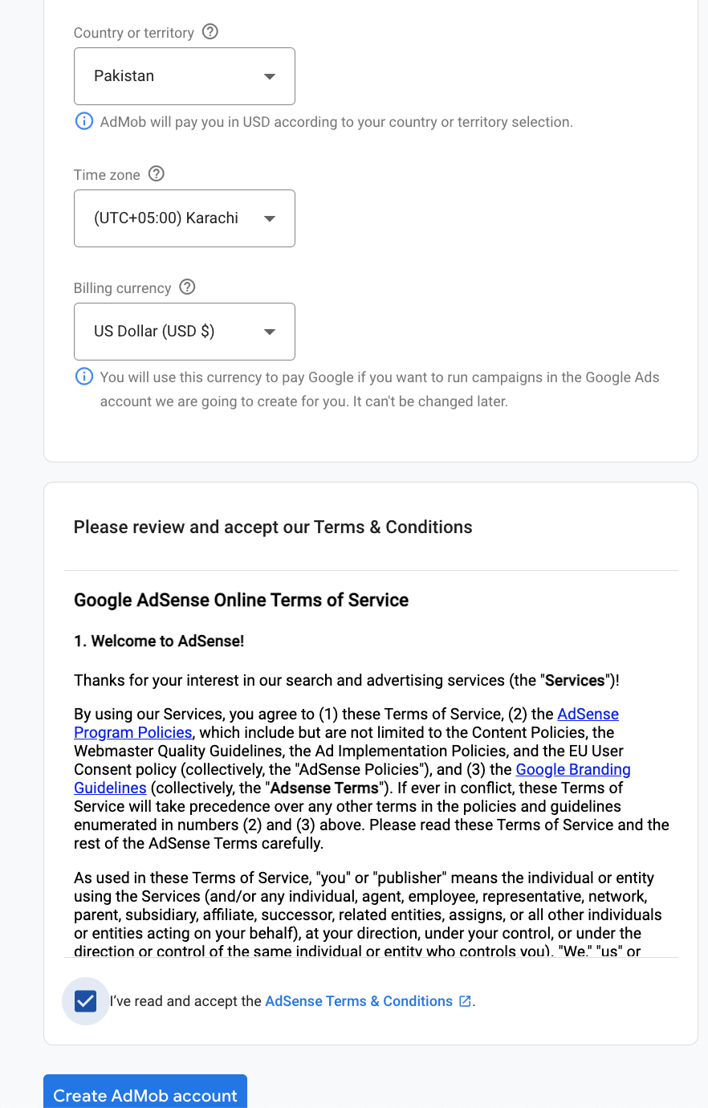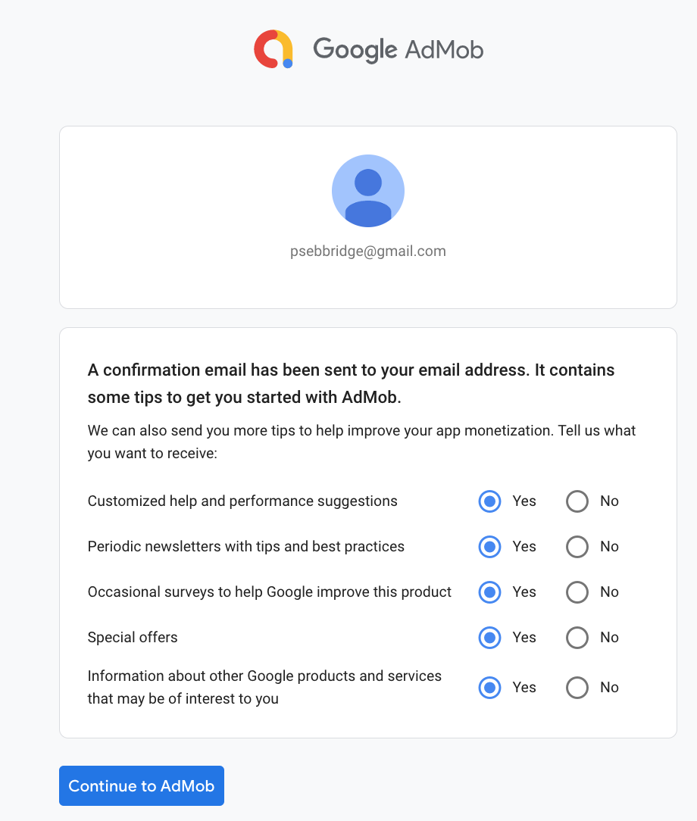

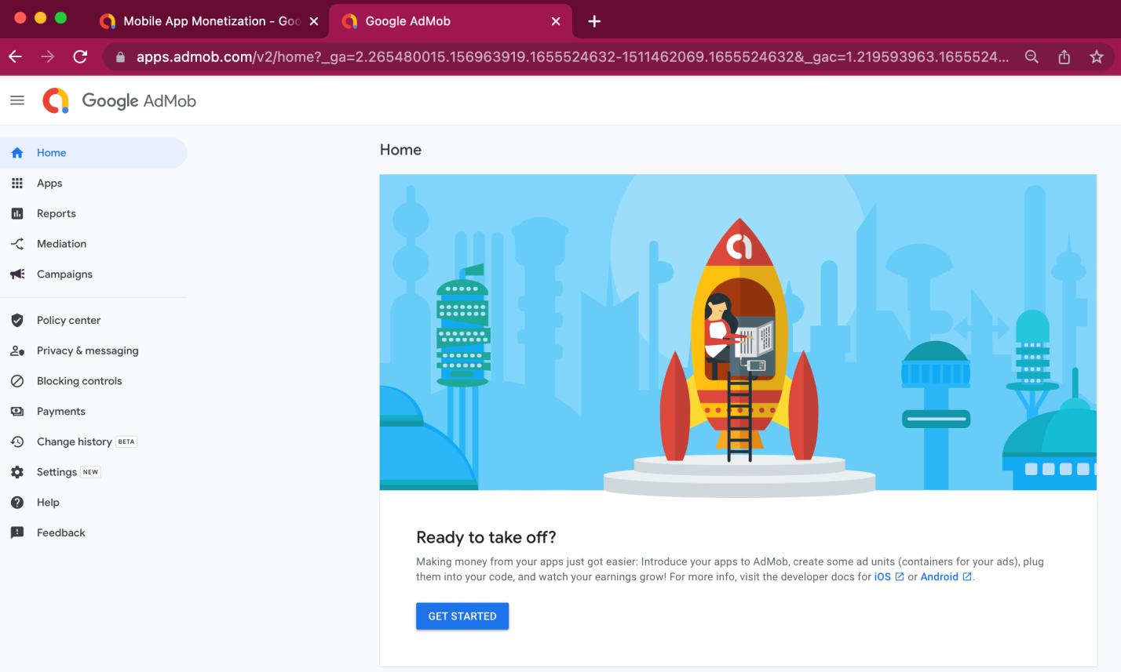

Once admob account is created then we add an app to it and then generate ad unit ids as follows

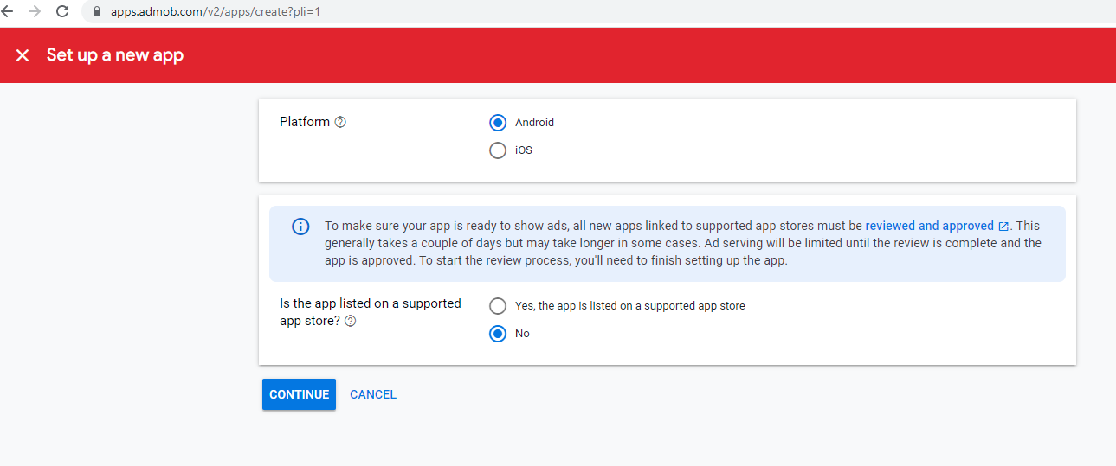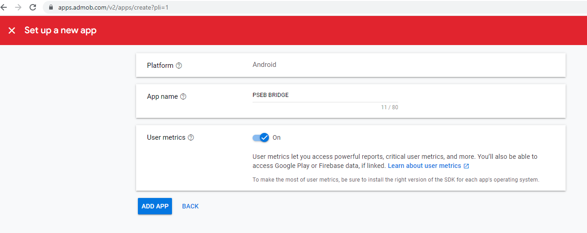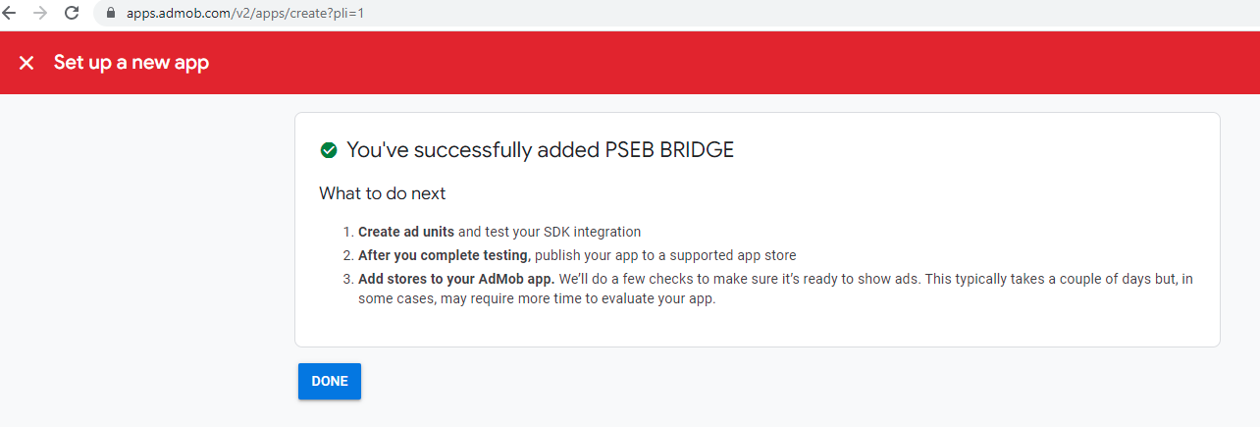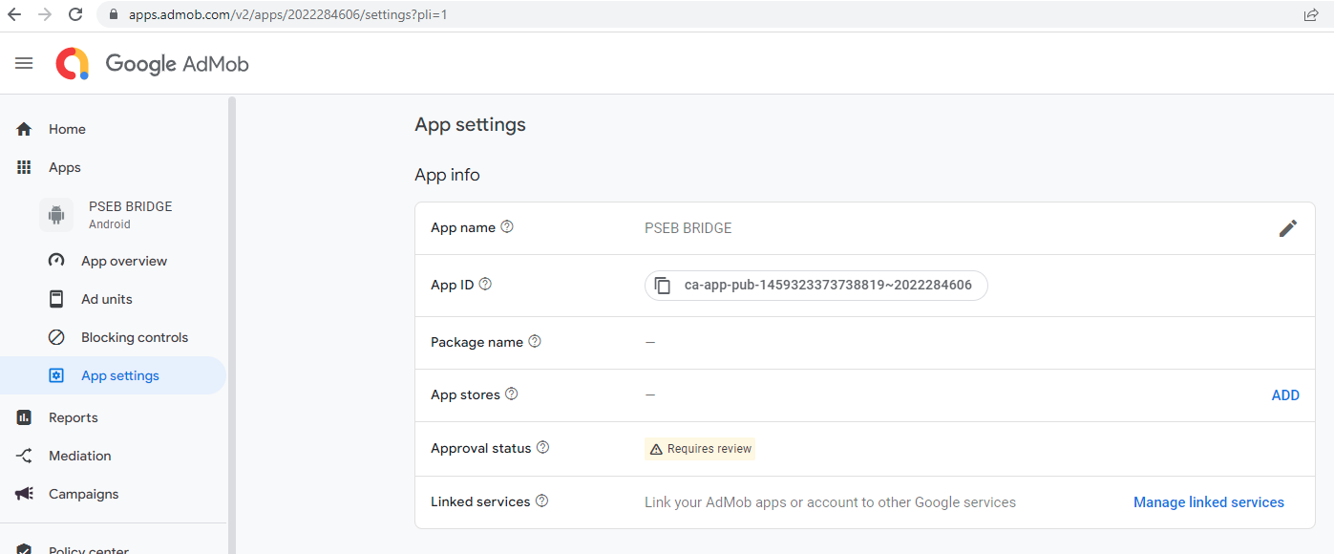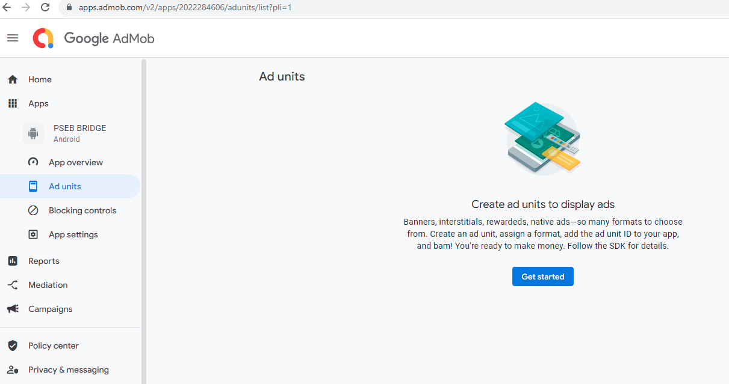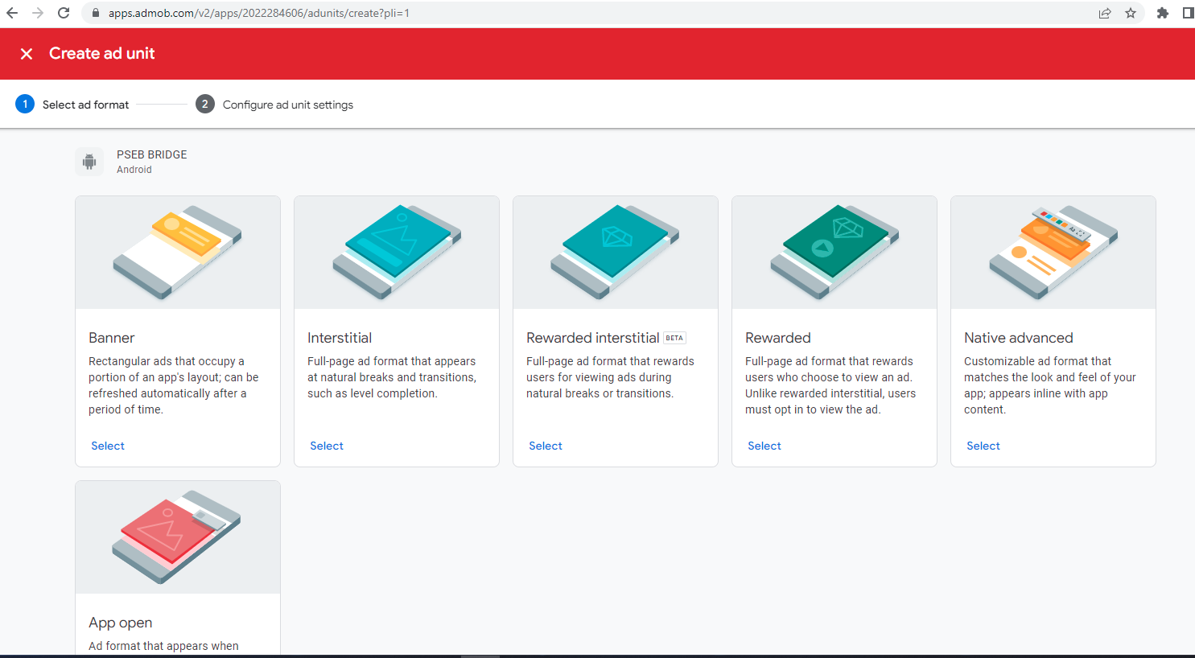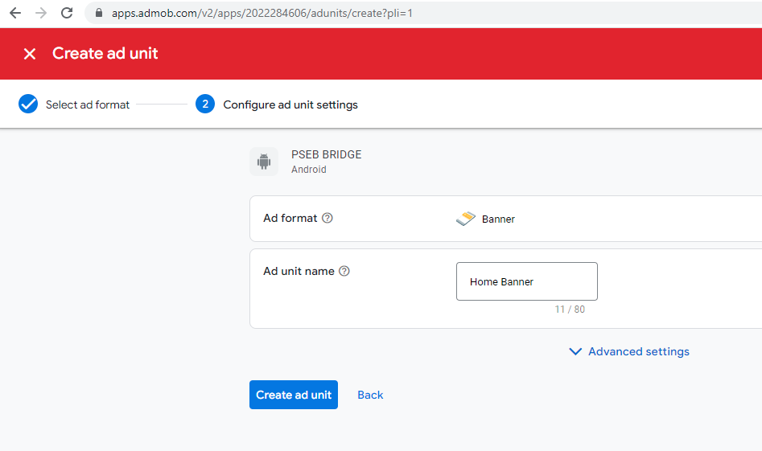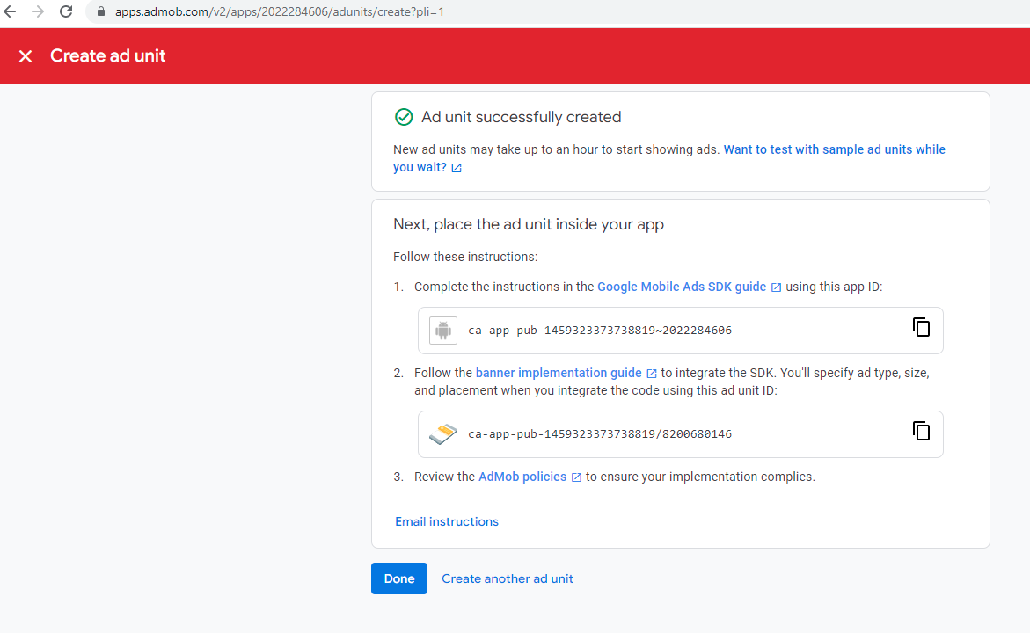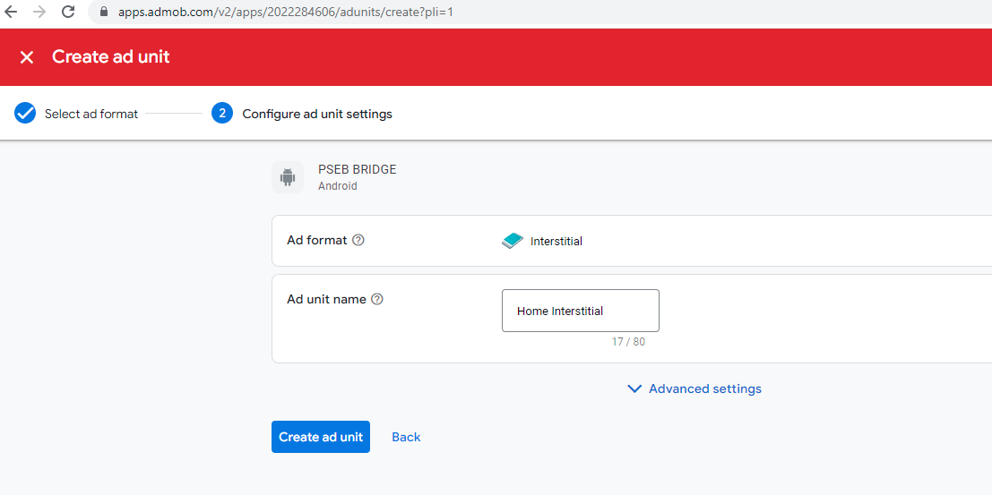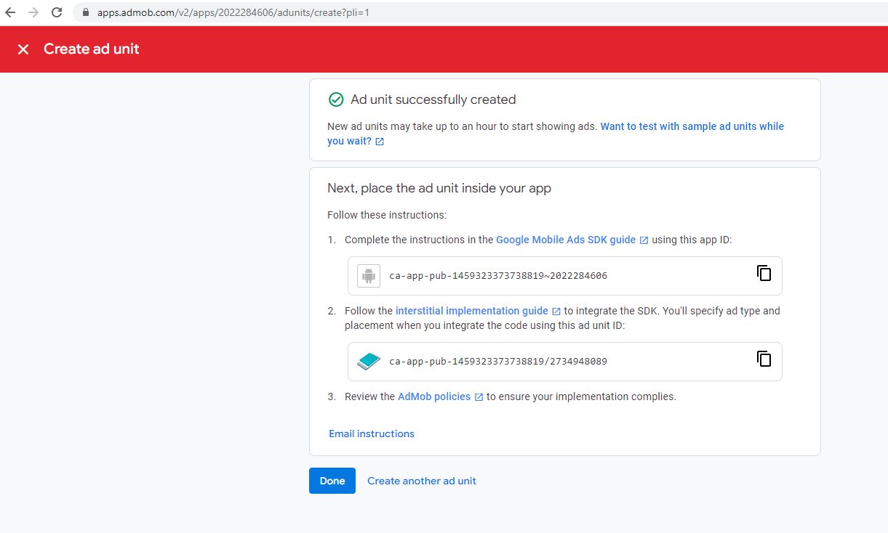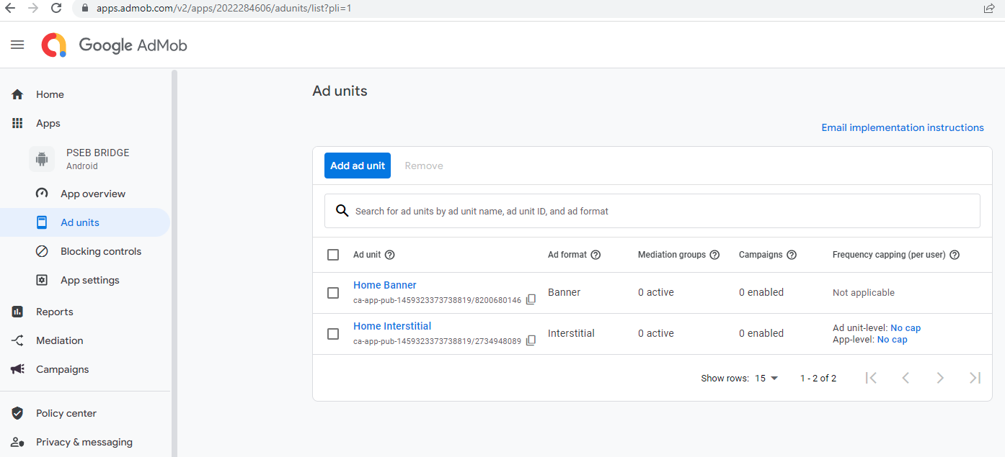

Then in our Flutter app we do the following steps

- Include the Google Mobile Ads SDK for Flutter plugin in your Flutter project.

- The AdMob app ID must be included in the AndroidManifest.xml. Failure to do so results in a crash on app launch.
<manifest>
<application>
<!-- Sample AdMob app ID: ca-app-pub-3940256099942544~3347511713 -->
<meta-data
android:name="com.google.android.gms.ads.APPLICATION_ID"
android:value="ca-app-pub-xxxxxxxxxxxxxxxx~yyyyyyyyyy"/>
<application>
<manifest>

- Initialize the Mobile Ads SDK
- Before loading ads, have your app initialize the Mobile Ads SDK by calling MobileAds.instance.initialize(), which initializes the SDK and returns a Future that finishes once initialization is complete (or after a 30-second timeout). This needs to be done only once, ideally right before running the app.

Source code
Main.dart

import 'package:admob_ads_monetization_pseb_bridge/screens/home_screen.dart';
import 'package:flutter/material.dart';
import 'package:google_mobile_ads/google_mobile_ads.dart';

void main() {
WidgetsFlutterBinding.ensureInitialized();
MobileAds.instance.initialize();
runApp(const MyApp());
}

class MyApp extends StatelessWidget {
const MyApp({Key? key}) : super(key: key);

// This widget is the root of your application.
@override
Widget build(BuildContext context) {
return MaterialApp(
title: 'Flutter Demo',
theme: ThemeData(
primarySwatch: Colors.blue,
),
home: const HomeScreen(),
);
}
}

Home_screen.dart

import 'dart:io';

import 'package:admob_ads_monetization_pseb_bridge/screens/second_screen.dart';
import 'package:flutter/material.dart';
import 'package:flutter/material.dart';
import 'package:flutter/material.dart';
import 'package:google_mobile_ads/google_mobile_ads.dart';

class HomeScreen extends StatefulWidget {
const HomeScreen({Key? key}) : super(key: key);

@override
State<HomeScreen> createState() => _HomeScreenState();
}

class _HomeScreenState extends State<HomeScreen> {

static final AdRequest request = AdRequest(
keywords: <String>['foo', 'bar'],
contentUrl: 'http://foo.com/bar.html',
nonPersonalizedAds: true,
);

InterstitialAd? _interstitialAd;
int _numInterstitialLoadAttempts = 0;
int maxFailedLoadAttempts = 3;

final BannerAd myBanner = BannerAd(
adUnitId: 'ca-app-pub-3940256099942544/6300978111',
size: AdSize.banner,
request: AdRequest(),
listener: BannerAdListener(),
);

void _createInterstitialAd() {
InterstitialAd.load(
adUnitId: Platform.isAndroid
? 'ca-app-pub-3940256099942544/1033173712'
: 'ca-app-pub-3940256099942544/4411468910',
request: request,
adLoadCallback: InterstitialAdLoadCallback(
onAdLoaded: (InterstitialAd ad) {
print('$ad loaded');
_interstitialAd = ad;
_numInterstitialLoadAttempts = 0;
_interstitialAd!.setImmersiveMode(true);
},
onAdFailedToLoad: (LoadAdError error) {
print('InterstitialAd failed to load: $error.');
_numInterstitialLoadAttempts += 1;
_interstitialAd = null;
if (_numInterstitialLoadAttempts < maxFailedLoadAttempts) {
_createInterstitialAd();
}
},
));
}

void _showInterstitialAd() {
if (_interstitialAd == null) {
print('Warning: attempt to show interstitial before loaded.');
return;
}
_interstitialAd!.fullScreenContentCallback = FullScreenContentCallback(
onAdShowedFullScreenContent: (InterstitialAd ad) =>
print('ad onAdShowedFullScreenContent.'),
onAdDismissedFullScreenContent: (InterstitialAd ad) {
print('$ad onAdDismissedFullScreenContent.');
ad.dispose();
_createInterstitialAd();
},
onAdFailedToShowFullScreenContent: (InterstitialAd ad, AdError error) {
print('$ad onAdFailedToShowFullScreenContent: $error');
ad.dispose();
_createInterstitialAd();
},
);
_interstitialAd!.show();
_interstitialAd = null;
}

@override
void initState() {
super.initState();
myBanner.load();
_createInterstitialAd();
}

@override
Widget build(BuildContext context) {
return Scaffold(
appBar: AppBar(
title: const Text('Admob Demo'),
),
body: Column(
children: [
Expanded(
child: Container(
child: Center(
child: ElevatedButton(
onPressed: () {

_showInterstitialAd();
Navigator.of(context).push(MaterialPageRoute(builder: (context){
return const SecondScreen();
}));
},
child: const Text('Go to second Screen'),
),
),
)),
Container(
alignment: Alignment.center,
width: myBanner.size.width.toDouble(),
height: myBanner.size.height.toDouble(),
child: AdWidget(ad: myBanner),
)
],
),
);
}
}

Second_screen.dart
import 'package:flutter/material.dart';

class SecondScreen extends StatefulWidget {
const SecondScreen({Key? key}) : super(key: key);

@override
State<SecondScreen> createState() => _SecondScreenState();
}

class _SecondScreenState extends State<SecondScreen> {
@override
Widget build(BuildContext context) {
return Scaffold(
appBar: AppBar(
title: const Text('Second Screen'),
),
);
}
}
Complete Source code available at
https://github.com/abidroid/admob_ads_monetization_pseb_bridge

